**Project Design Phase-II**

**Data Flow Diagram & User Stories**

|  |  |
| --- | --- |
| Date | 03 October 2022 |
| Team ID | PNT2022TMID42634 |
| Project Name | A Novel Method For Handwritten Digit Recognition System |
| Maximum Marks | 4 Marks |

**Data Flow Diagrams:**

Example: DFD Level 0 (Industry Standard)

**Example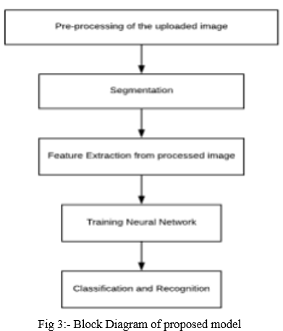s:**

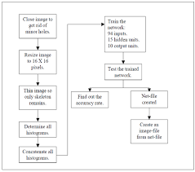

| **User Type** | **Functional Requirement (Epic)** | **User Story Number** | **User Story / Task** | **Acceptance criteria** | **Priority** | **Release** |
| --- | --- | --- | --- | --- | --- | --- |
| Customer (Mobile user) | Registration | USN-1 | As a user, I will receive confirmation email once I have registered for the application | I can access my account / dashboard | High | Sprint-1 |
|  |  | USN-2 | As a user, I can log into the application by entering email & password | I can receive confirmation email & click confirm | High | Sprint-1 |
|  |  | USN-3 | As a user, I can view the application’s home page where I can read the instructions to use this application | I can register & access the dashboard with Facebook Login | Low | Sprint-2 |
|  |  | USN-4 | As a user, I can able to input the images of digital documents to the application | As a user, I can able to input the images of digital documents to the application | Medium | Sprint-1 |
|  | Login | USN-5 | As a user I can able to get the recognised digit as output from the images of digital documents or images | I can access the recognized digits from digital document or images | High | Sprint-1 |
|  | Dashboard | USN-6 | As a user, I will train and test the input to get the maximum accuracy of output. | I can able to train and test the application until it gets maximum accuracy of the result | High | Sprint 3 |
| Customer (Web user) | Accessbility | USN-8 | As a user, I can use the web application virtually anywhere. | I can use the application in any device with a browser | Low | Sprint 4 |